Using Audacity to layer sound files together
Creating a newsflash for example.
Basic tools in Audacity

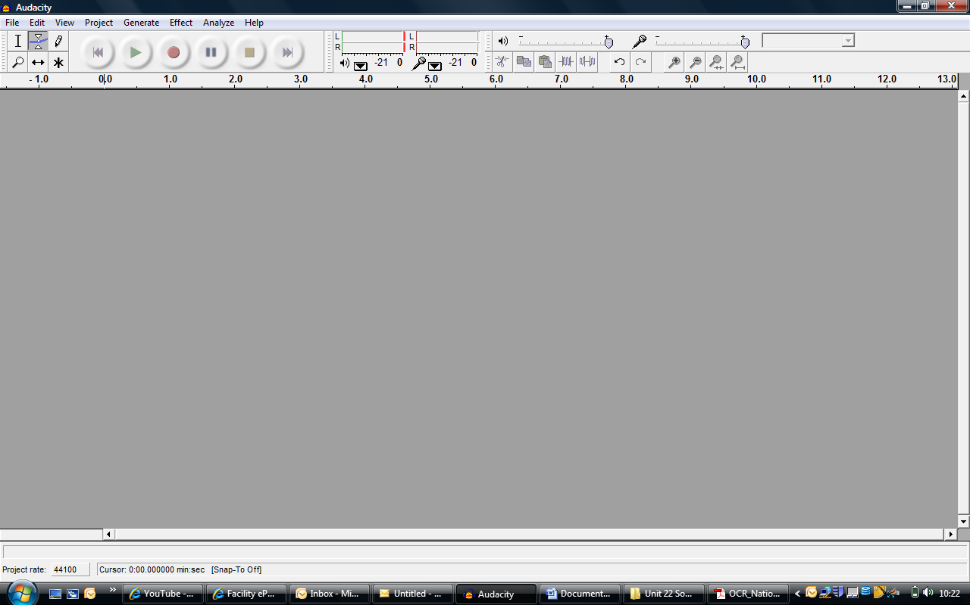
Select parts of sound files

Adjust the profile of sound clips (fade in and fade out)

Move sound files

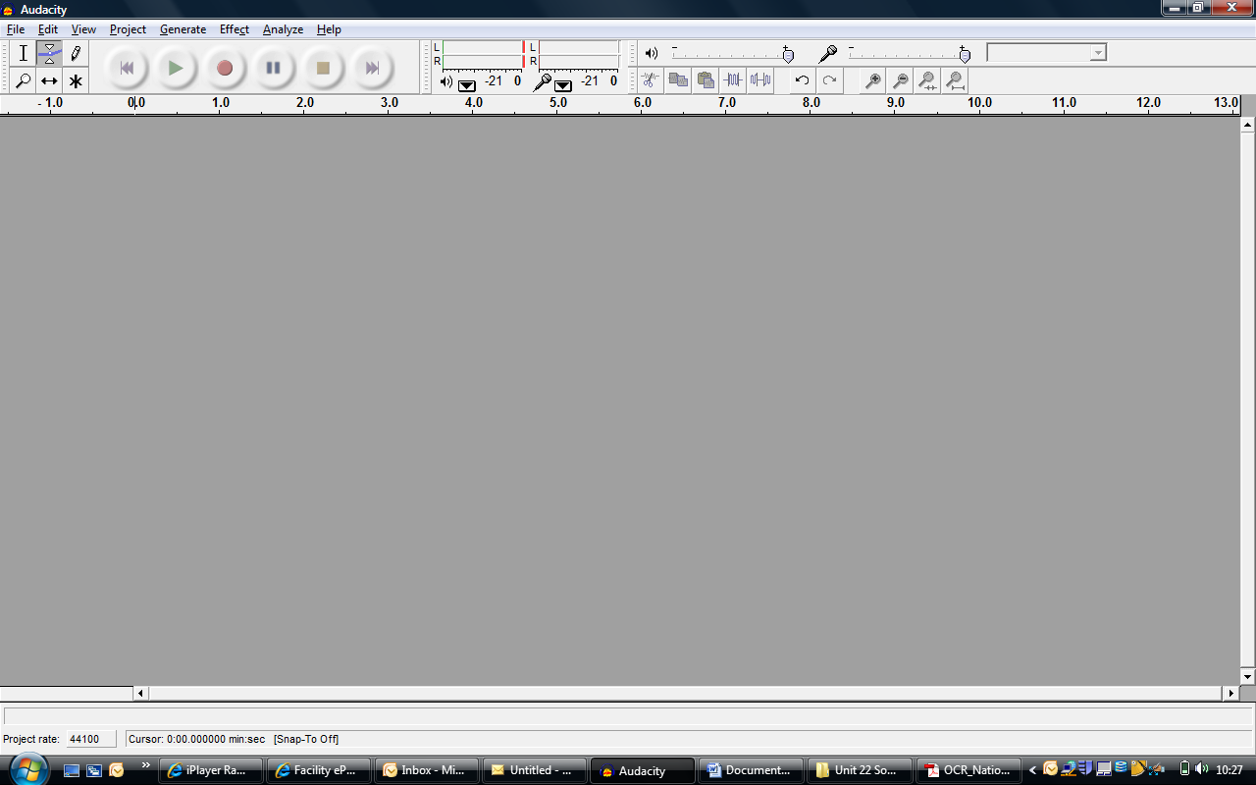
Rewind Play Record Pause Stop Forward
Recording the news speech
Click the record button and start talking. It helps to have a script and practice a bit. Press stop to finish. Here I have recorded 4 segments for my ‘Radio show’. The second one was a mistake so I will delete it. Click here.
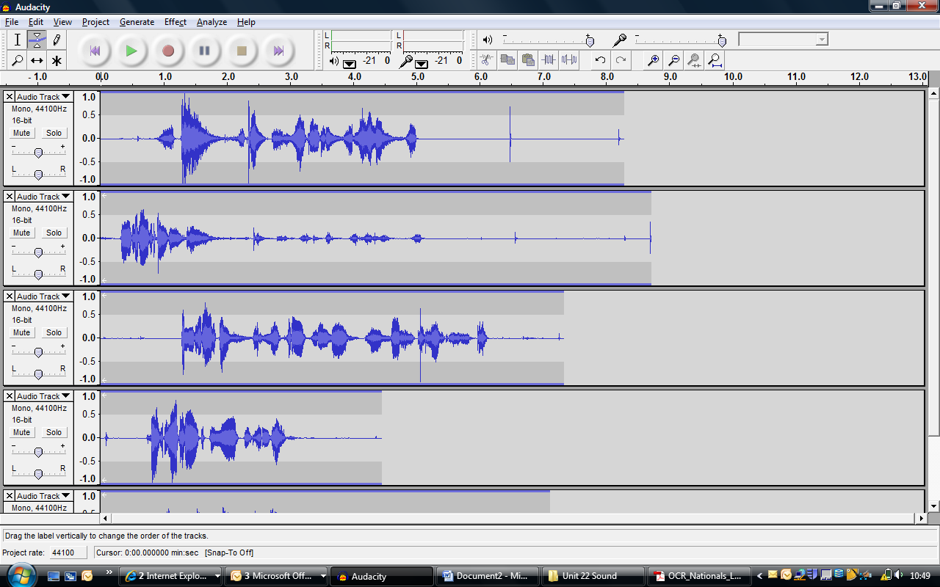
Adjusting the sound clips.
The solo button allows you to listen to only that clip. I will use this when I trim my clips.
At the start of the first clip I coughed so I need to delete that bit. Using the tool. I select the bit I want to get rid of and then press the delete key.
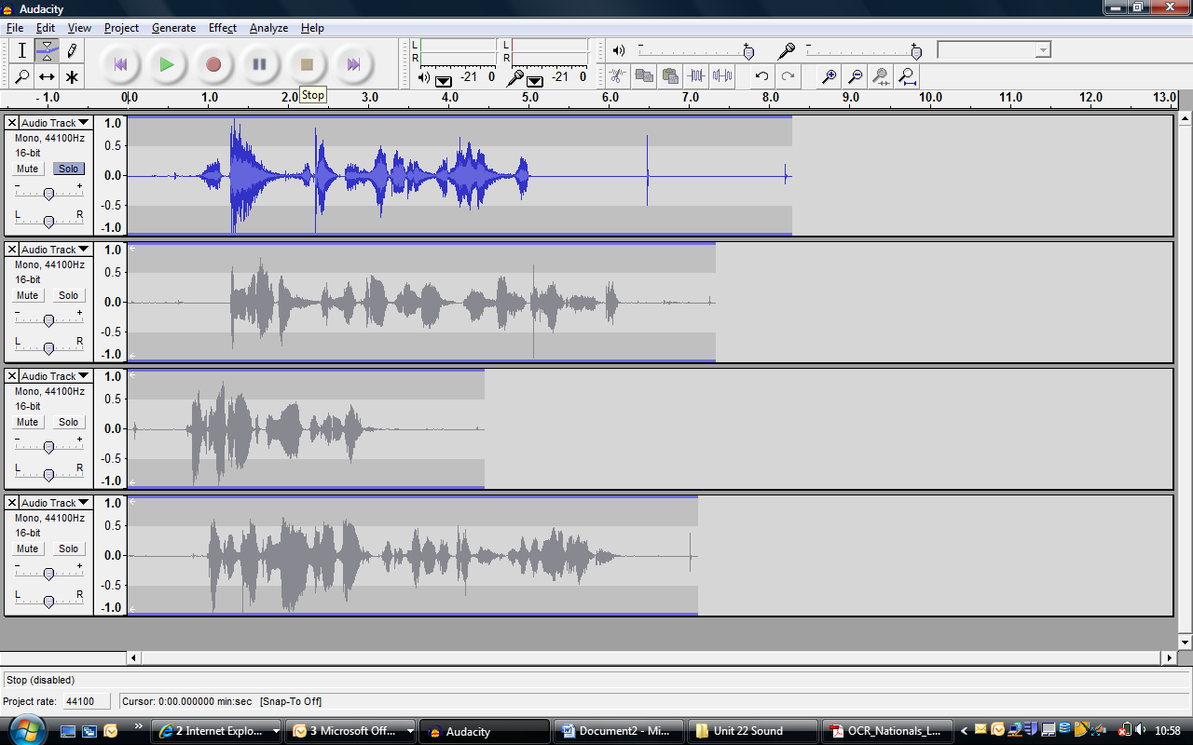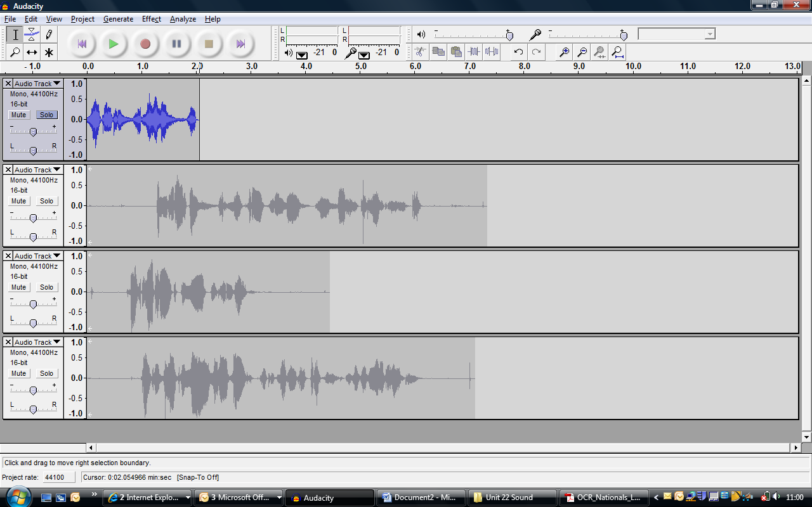
I now have just the bit I want. I will now trim the rest of the clips.
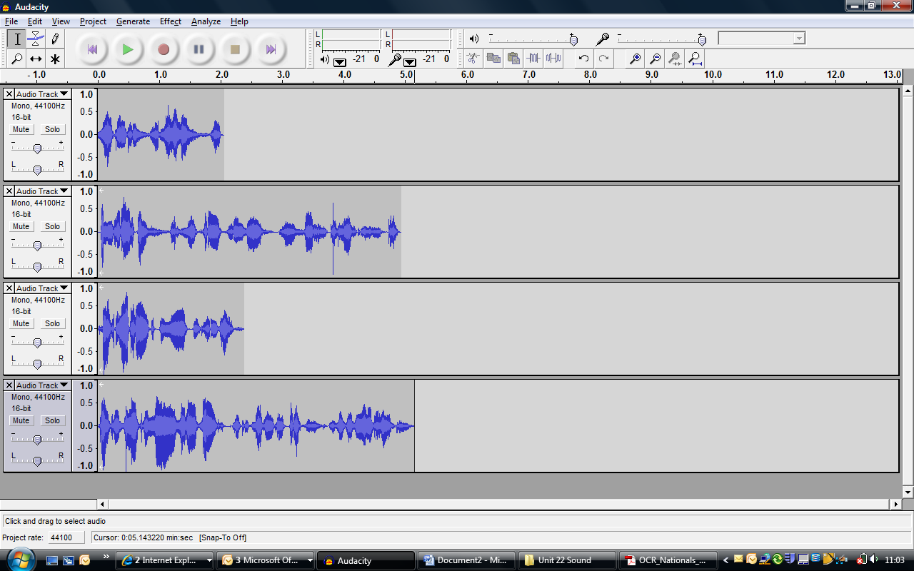

Now to add the music tracks.
Importing Audio clips. You can use MP3, WAV and FLV But NOT WMA files.
Project – Import Audio
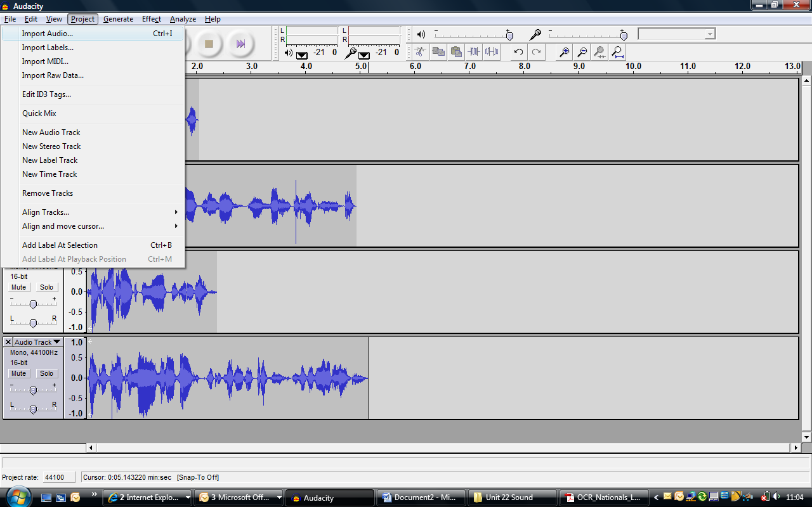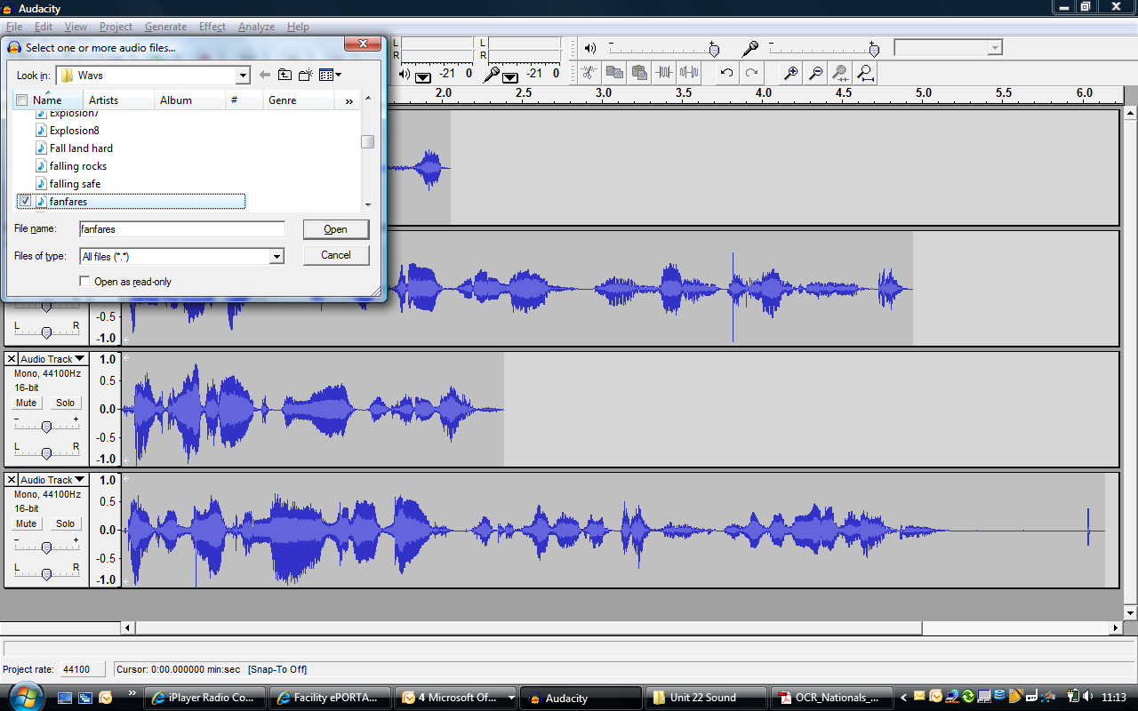
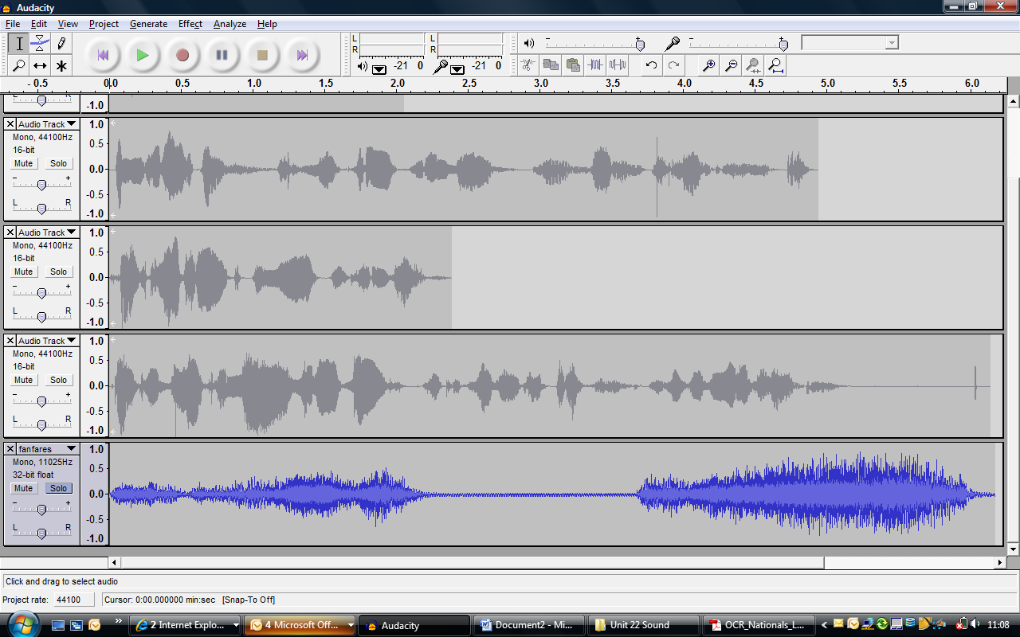
The clip appears at the bottom of the screen. You can click and drag it up to the top if you want it at the start. Drag from here.
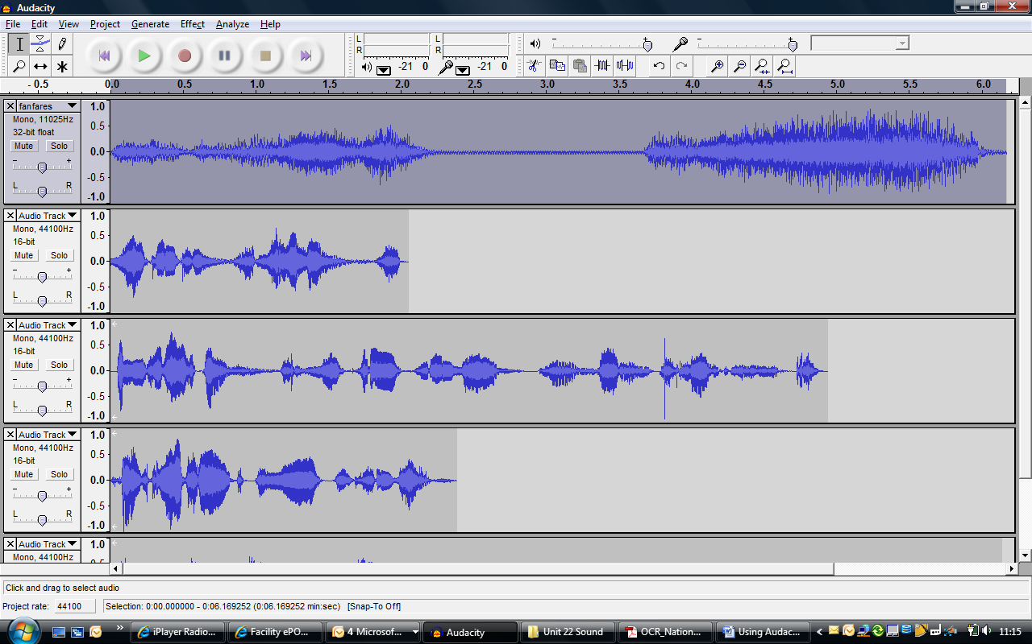

Give it a quick trim and move my opening speech. I cut the end off the 1st clip. I have now got half before my introduction and half after it
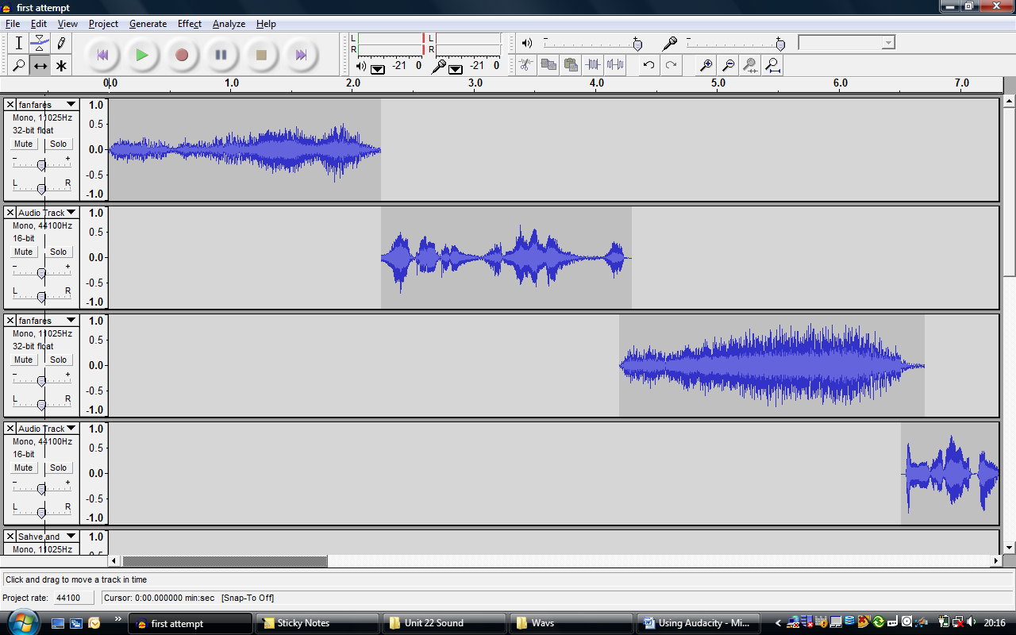
Fading in or out.
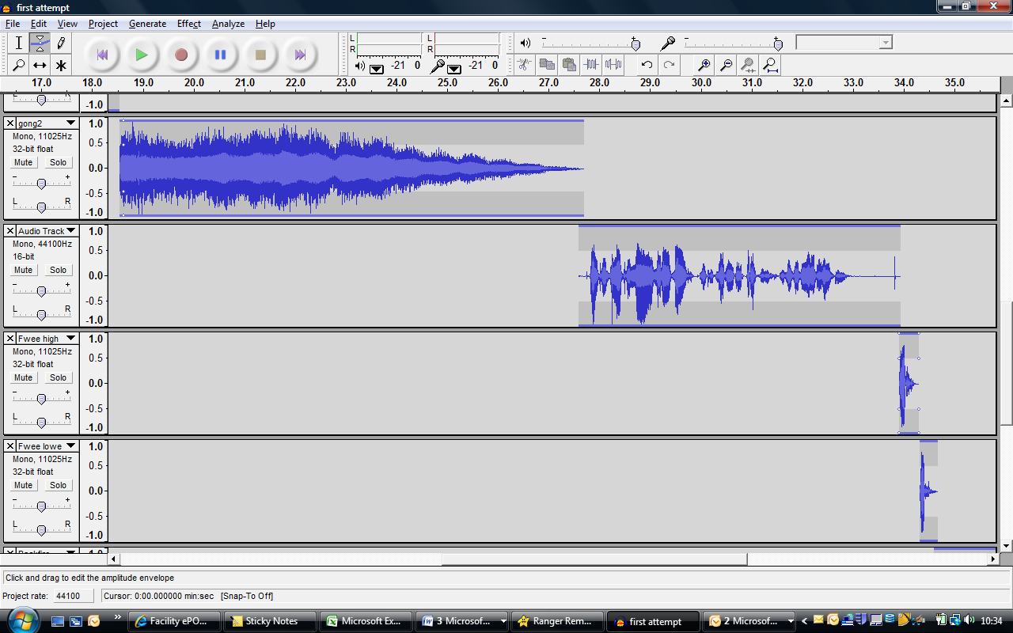
I have selected the Envelope tool and clicked on the clip I want to fade in.
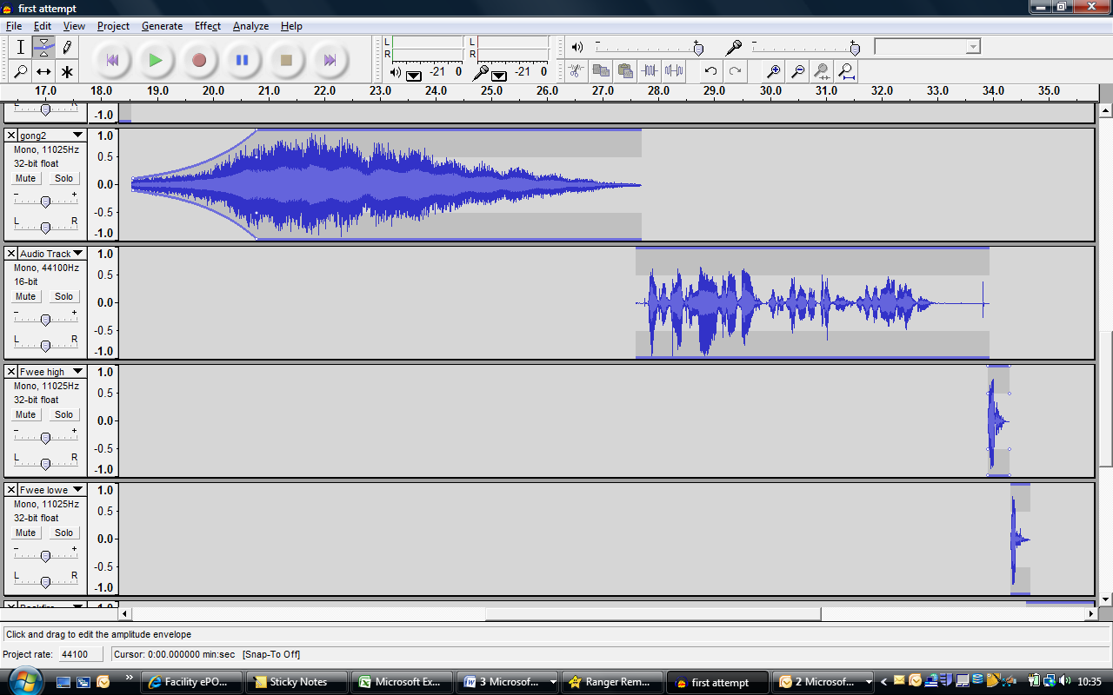
I then click and drag to change the shape of the clip to make it fade in.

As your project gets more complicated you might need to zoom out to see all the clips.
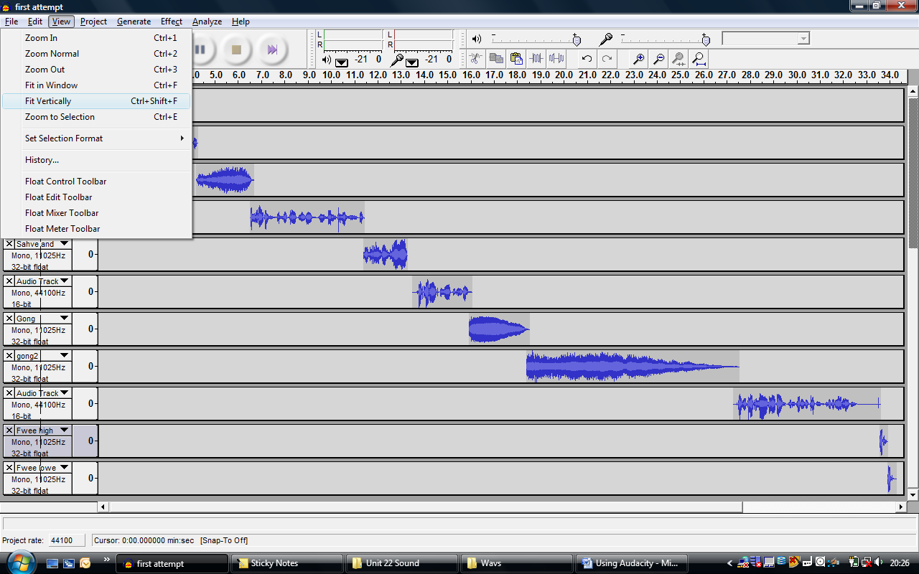
Finally, when you have completed editing the clip.
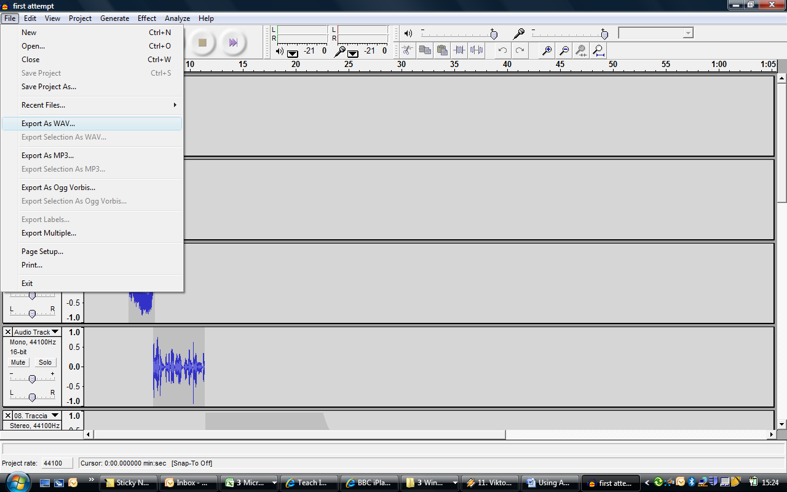 Export it as a Wav file and save it for assessment.

